**ONLINE RESTAURANT ORDERING SYSTEM**

Table of Contents

Welcome Screen 3

Add Item Menu 4

Customer Orders 5

View Orders Page 6

# Welcome Screen

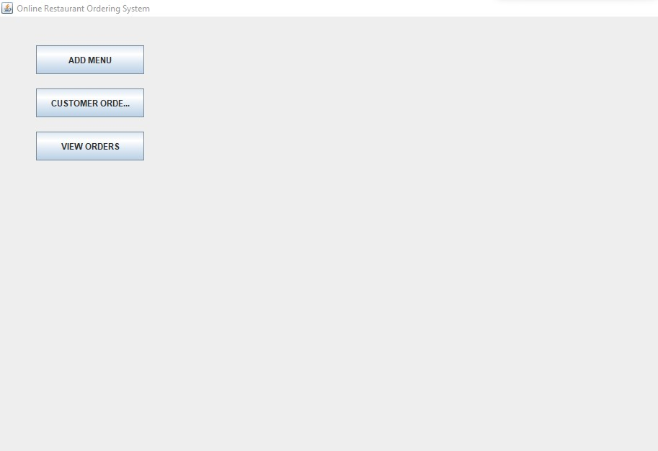

Above is the Welcome screen which launches first when you run or use the application. The Welcome Screen contains three buttons which takes you to three different pages which is the add menu page, customer order and the view orders.

# Add Item Menu

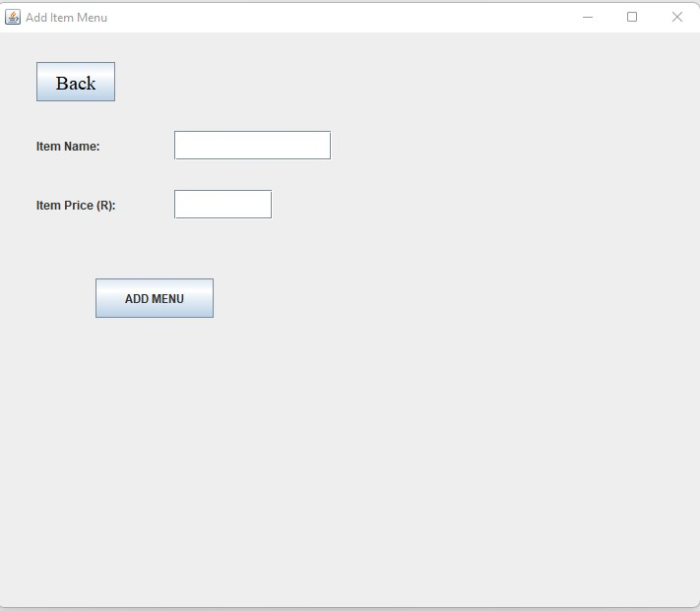

This is the add item Menu page which launches after you click the add the menu button from the Welcome Screen. On this page you able to add the menu which is available in the restaurant. It also contains the back button which takes you back to the Welcome Screen.

# Customer Orders

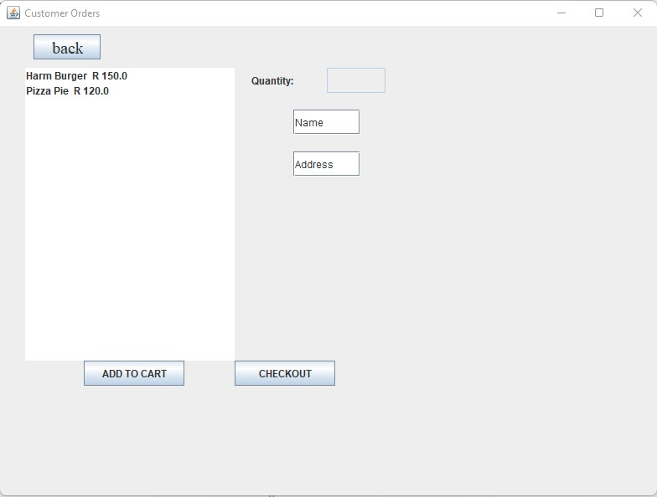

This is the customer orders page which launches after you click the customer orders button from the Welcome Screen. On this page a customer is able to order by first filling in their name and address, selecting items menu available as well as the quantity. It also contains the back button which takes you back to the Welcome Screen.

# View Orders Page

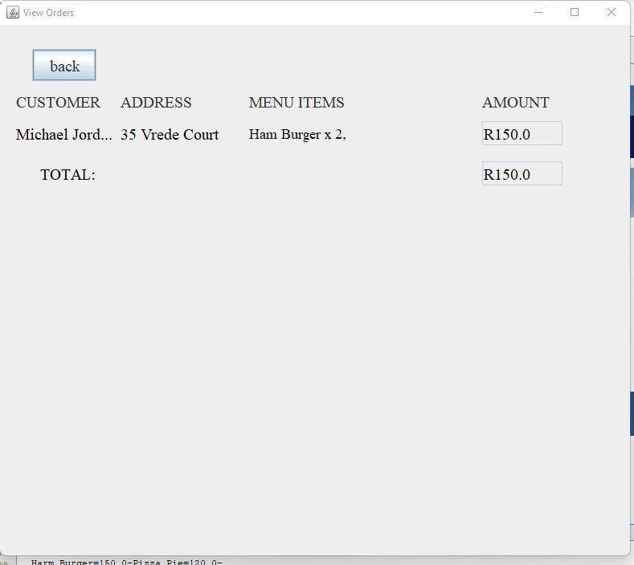

This is the View Orders page which launches after you click the view orders button from the Welcome Screen. On this page the restaurant is able to view the orders placed by the customers. It also contains the back button which takes you back to the Welcome Screen.